**City Council Turnout Analysis**

We examine the change in voter turnout over the various CC election years (2011, 2013, 2015, and 2017).[1] We are answering an essential question: **How has voter turnout by precinct changed across city council election year**?

**Part 1: “Volatility” of Voter Turnout**

To begin, we examine the volatility of voter turnout in each election year. Here we are examining the voter turnout of each specific precinct, that is, the percentage of registered voters in a specific precinct who cast a ballot in the election.

First finding the mean:

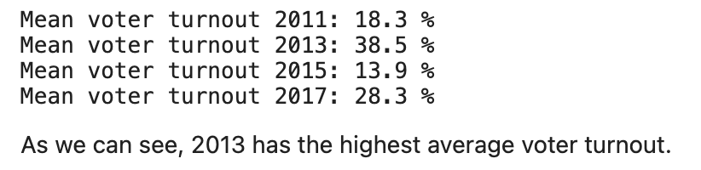

Then the median:

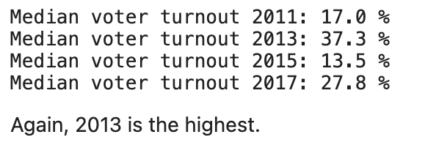

Finding that 2013 and 2017 had the highest voter turnout rates across all precincts due to the fact that they coincided with the Mayoral Elections of those same years.

Next, we determine the “Top 20 Precincts” which have the most volatile voter turnout. That is, have the greatest average change in voter turnout in that specific precinct based on election year. Listed in descending order:

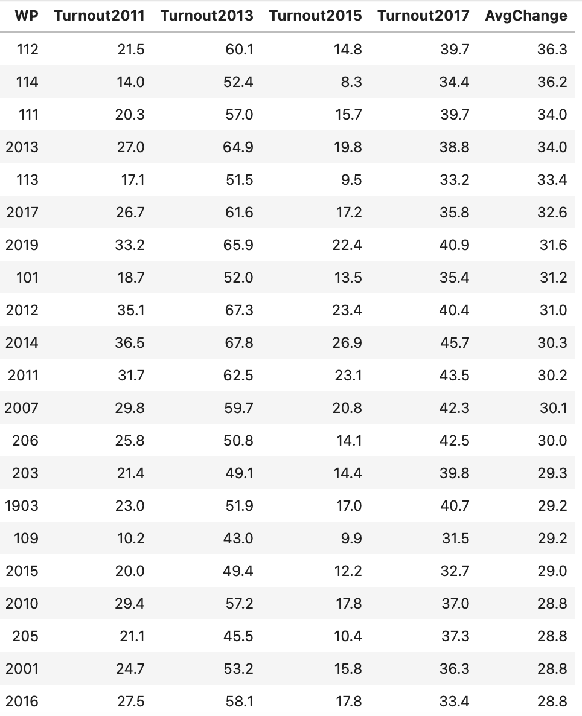

Simply from looking at the raw data, we can see that Ward 1 (East Boston), sees a lot of volatility.

Visualizing this change across elections on a bar chart, we have:

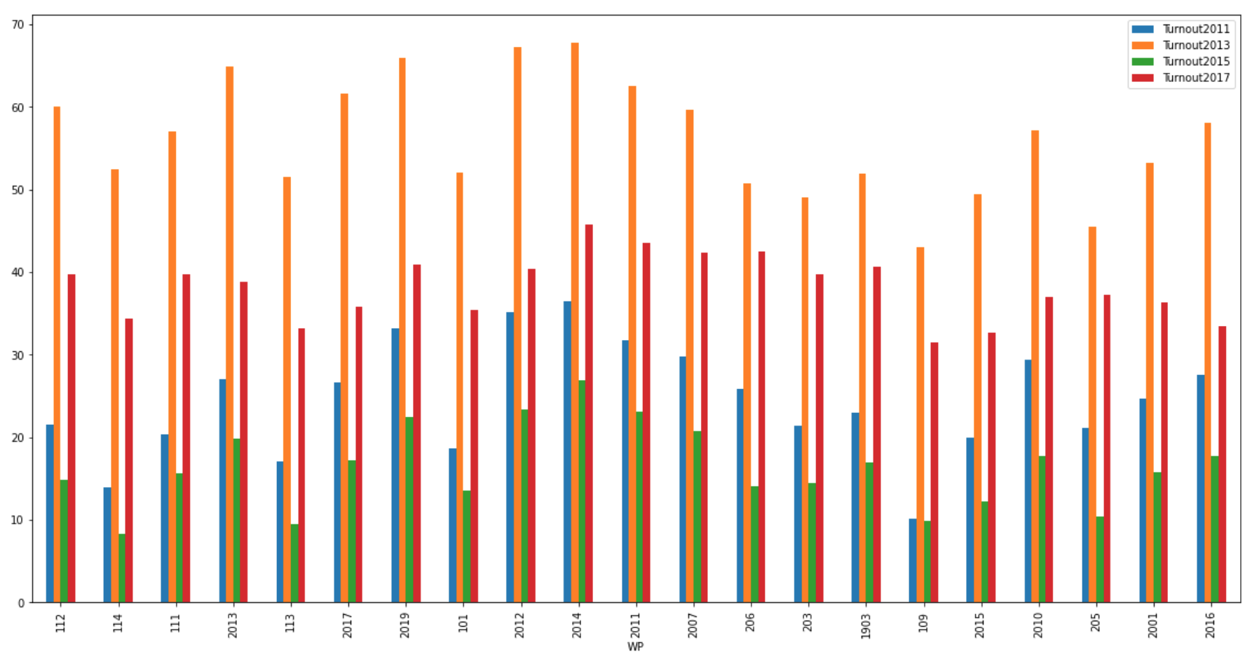

We can clearly see that voter turnout is highly volatile across each of these precincts.

Listing the demographic breakdown of each of these precincts:

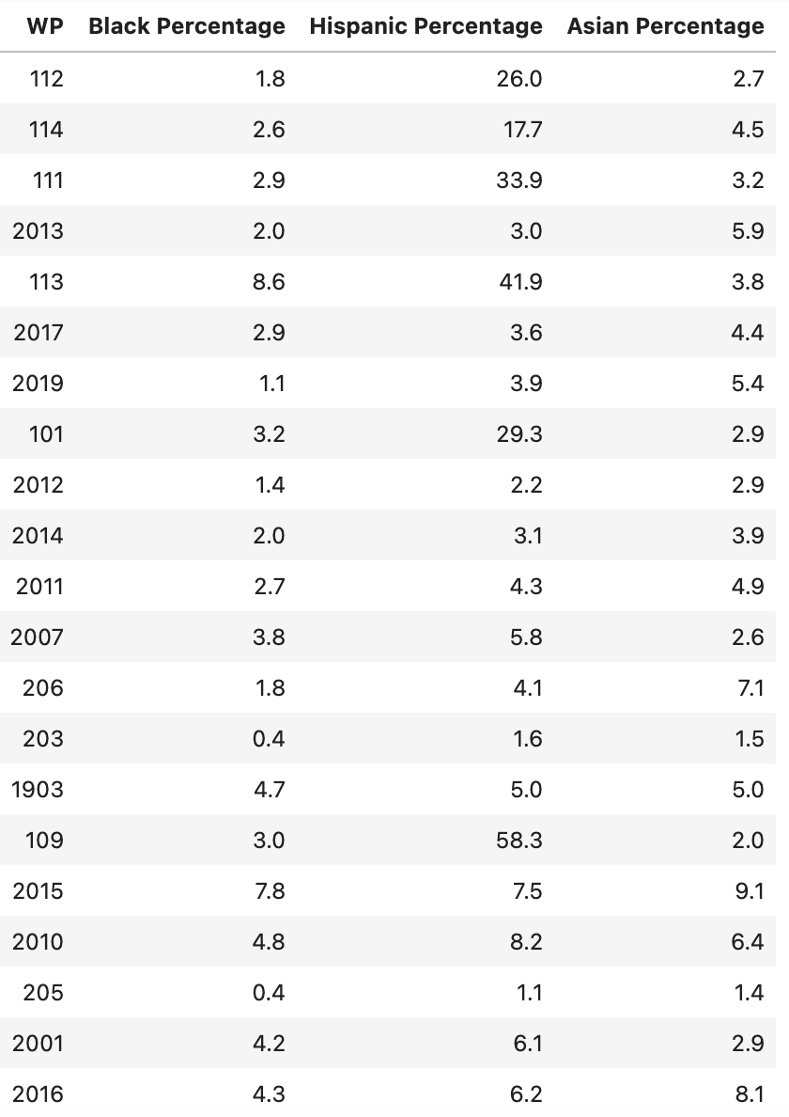

Now, we do a demographic breakdown of each of these precincts, finding the following:

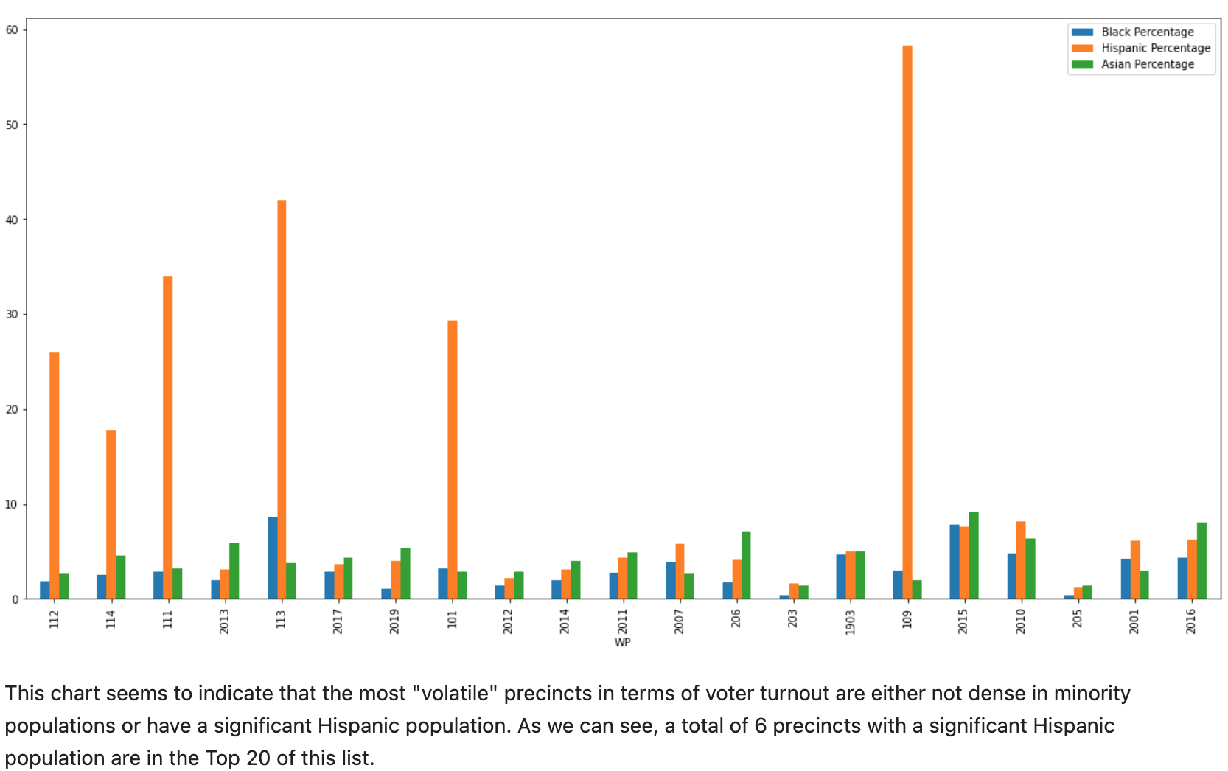

And viewing these precincts on a Boston map, we again see the concentration of precincts in East Boston as well as a concentration in West Roxbury:

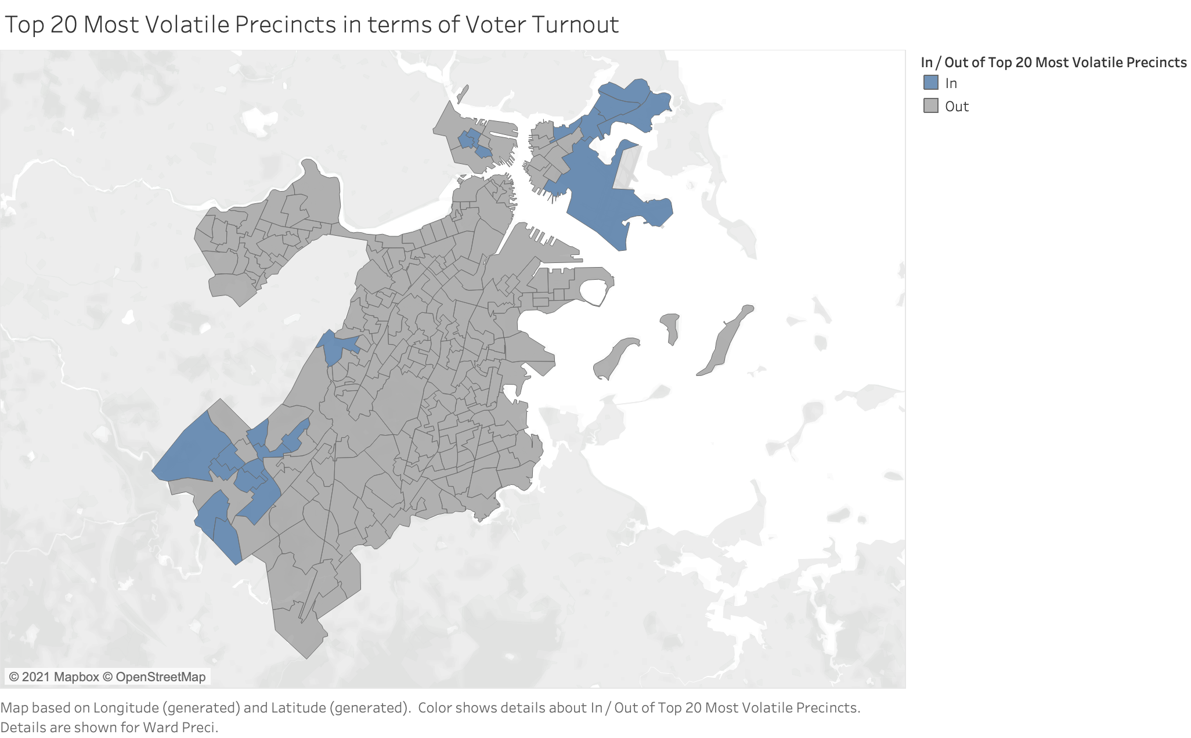

Additionally, we can use a heat map to visualize which districts experience the most volatility across city council elections:

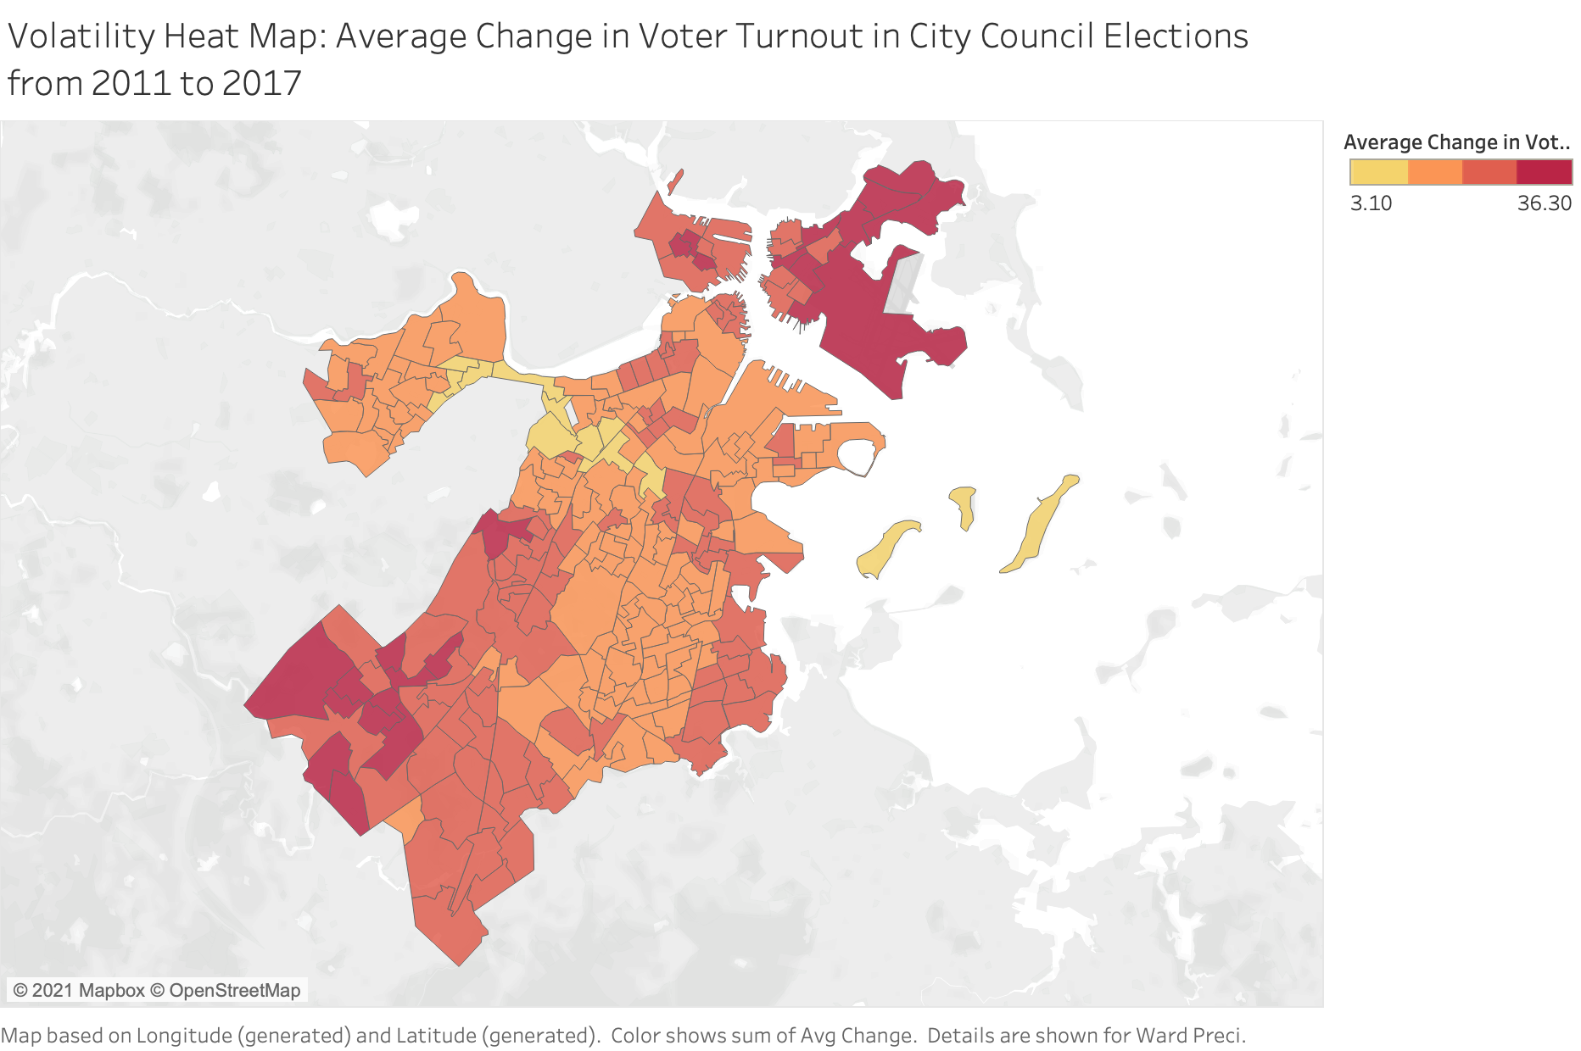

**Part 2: Changes in Share of Voter Turnout**

We now analyze which precincts experienced the greatest average change in *share of voter turnout* over time. That is, we are analyzing what percentage of the total votes cast for this particular election is from each precinct, and then analyzing the precincts which experienced the greatest change.

**Metric**: For each precinct, we calculate the percent share of votes: [Number of Ballots Cast in Precinct X]/[Total Ballots Cast in CC Election YYYY] * 100.

First, we find the top 20 precincts with the greatest average change in share of voters across each election. Note that these top 20 could be experiencing either significant negative or positive change.

Looking at the raw data:

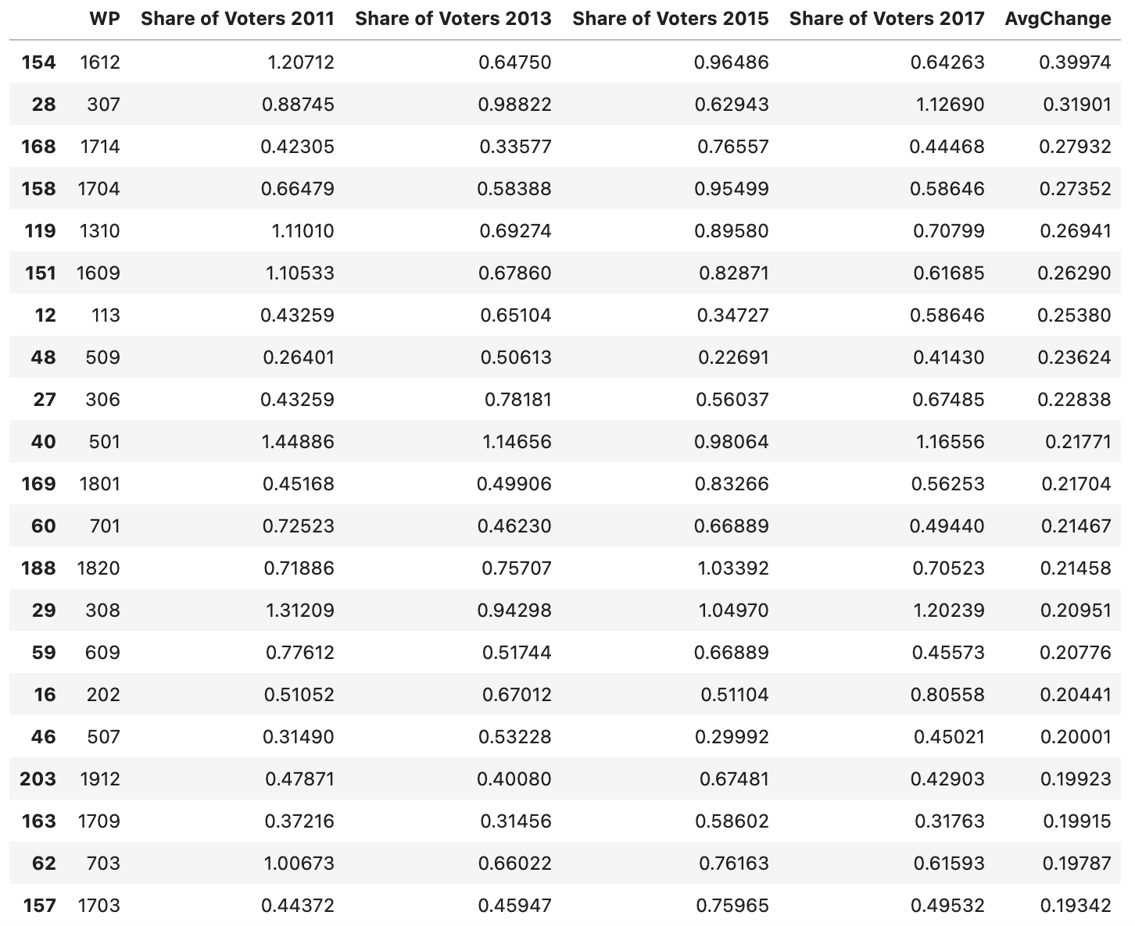

From the raw data, we can see that some of the top 20 precincts that experienced the greatest average change had a significant decrease in the share of voters (Example: WP 1612), while others like WP 509 saw significant dips up and down across election year.

Visualizing, on a bar chart, the percent share of voters of each of these top 20 precincts:

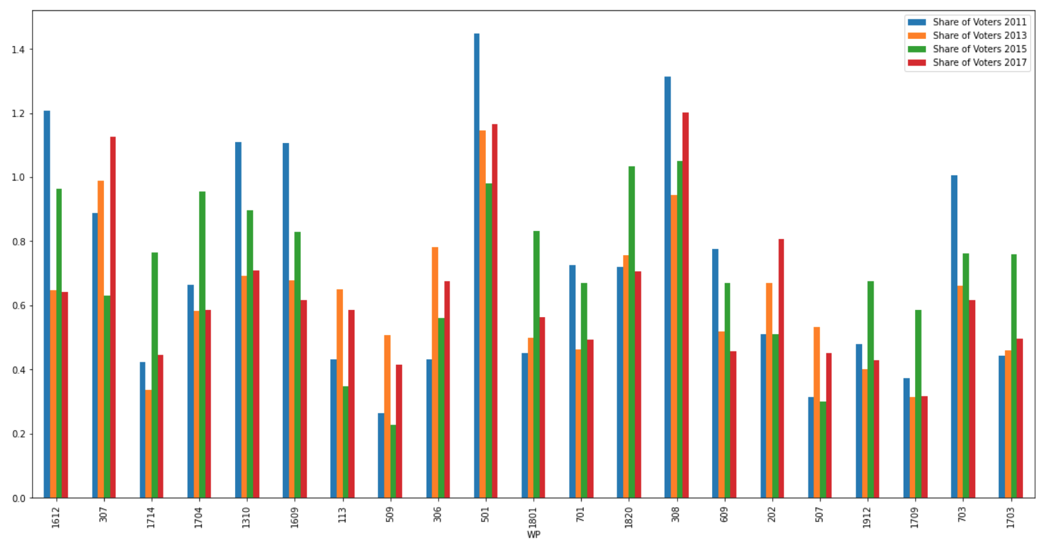

We can clearly see that the voter turnout has changed dramatically across each election in each of these precincts.

Listing the demographic breakdown of these precincts:

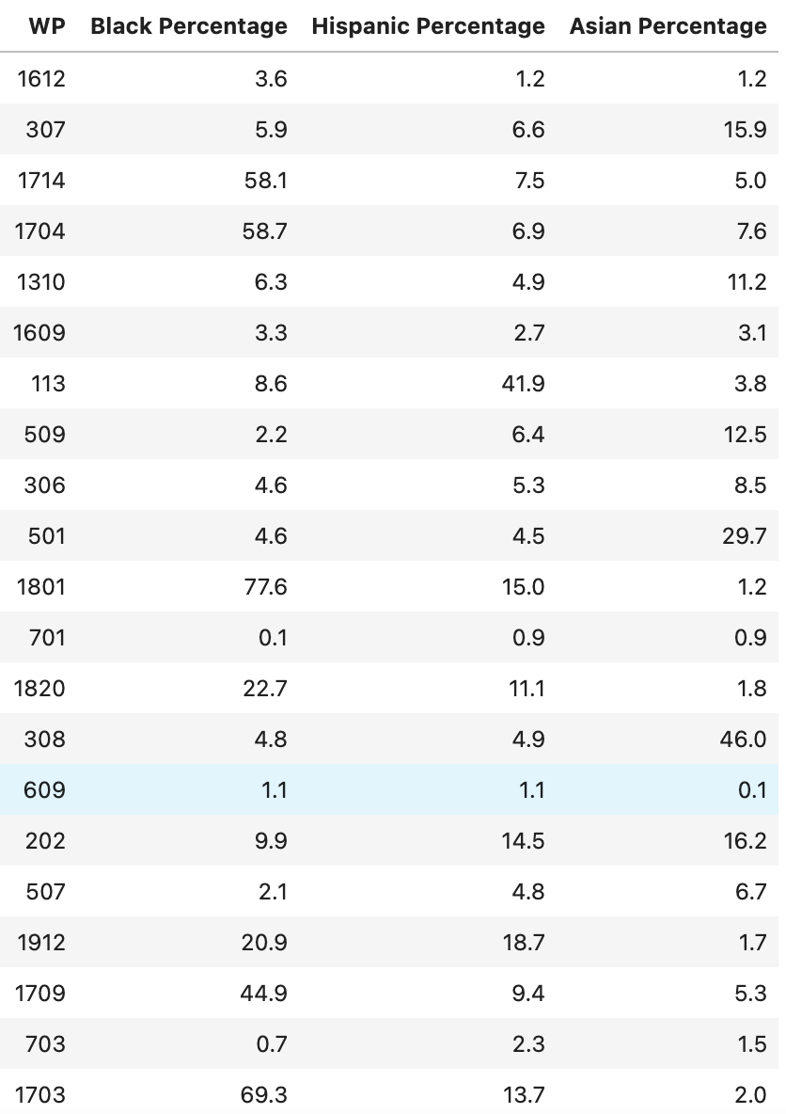

Now, visualizing the demographic breakdown of each of these precincts:

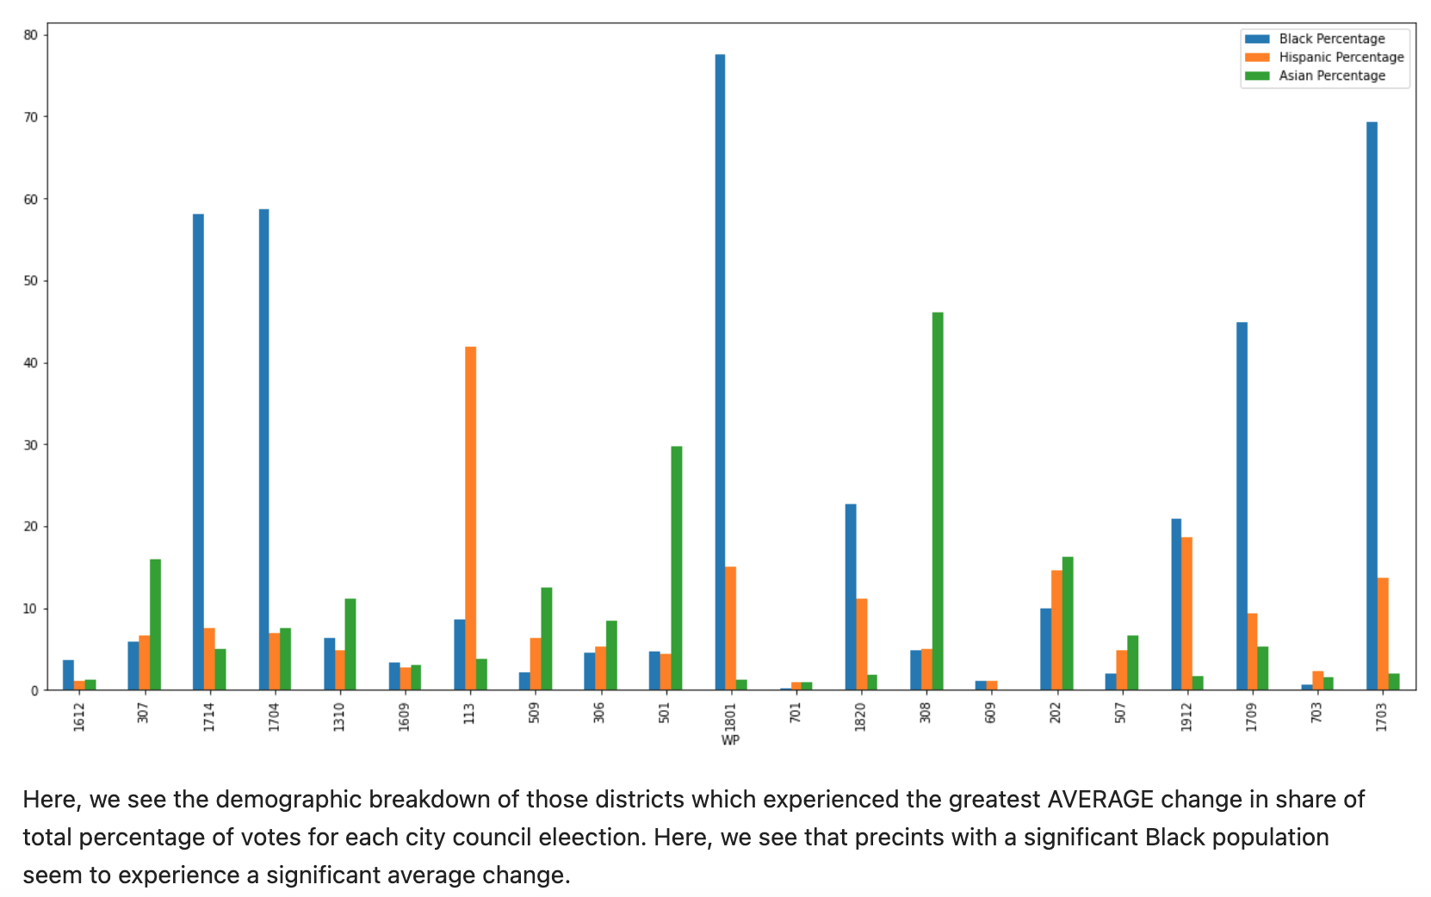

Visualizing on a map the geographic distribution of each of these precincts:

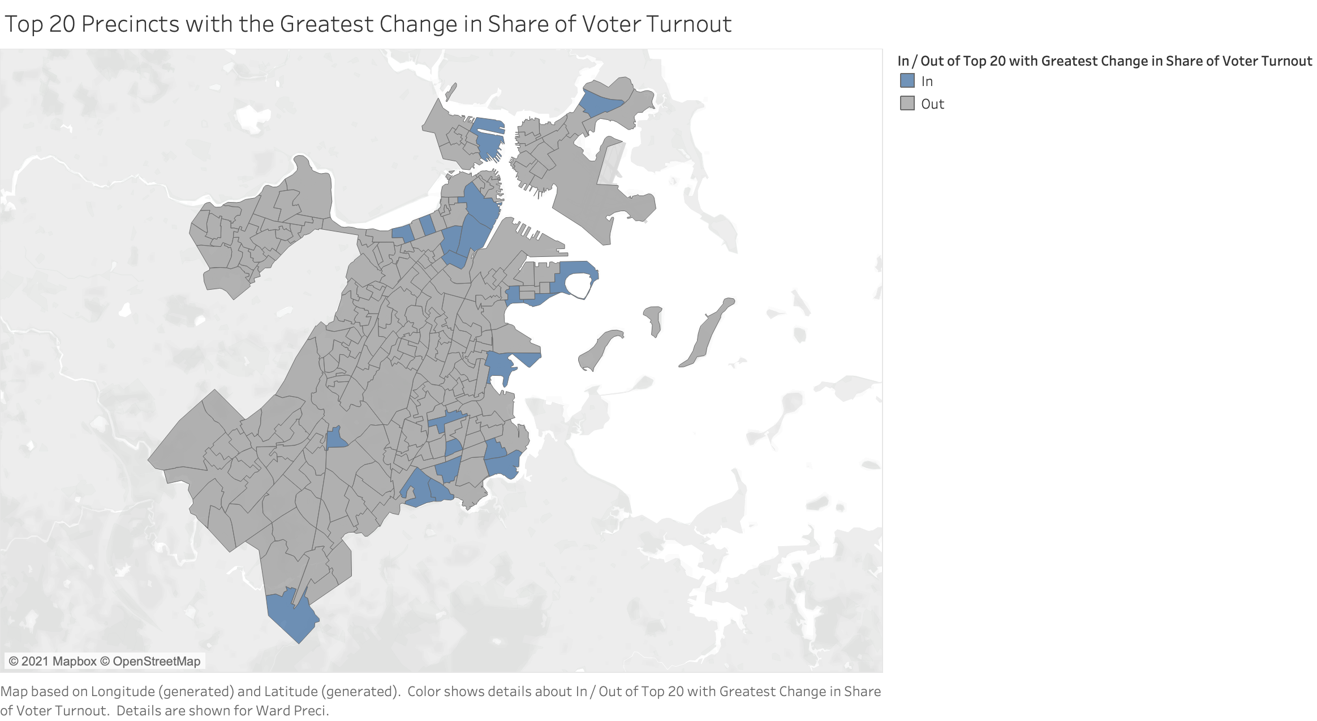

Here, we see that these precincts are a bit more scattered across Boston, but there is a slight concentration in Ward 17, an area of Dorchester. From our previous analysis, we also found that these same districts have a high Black population.

Viewing this information on a heat map:

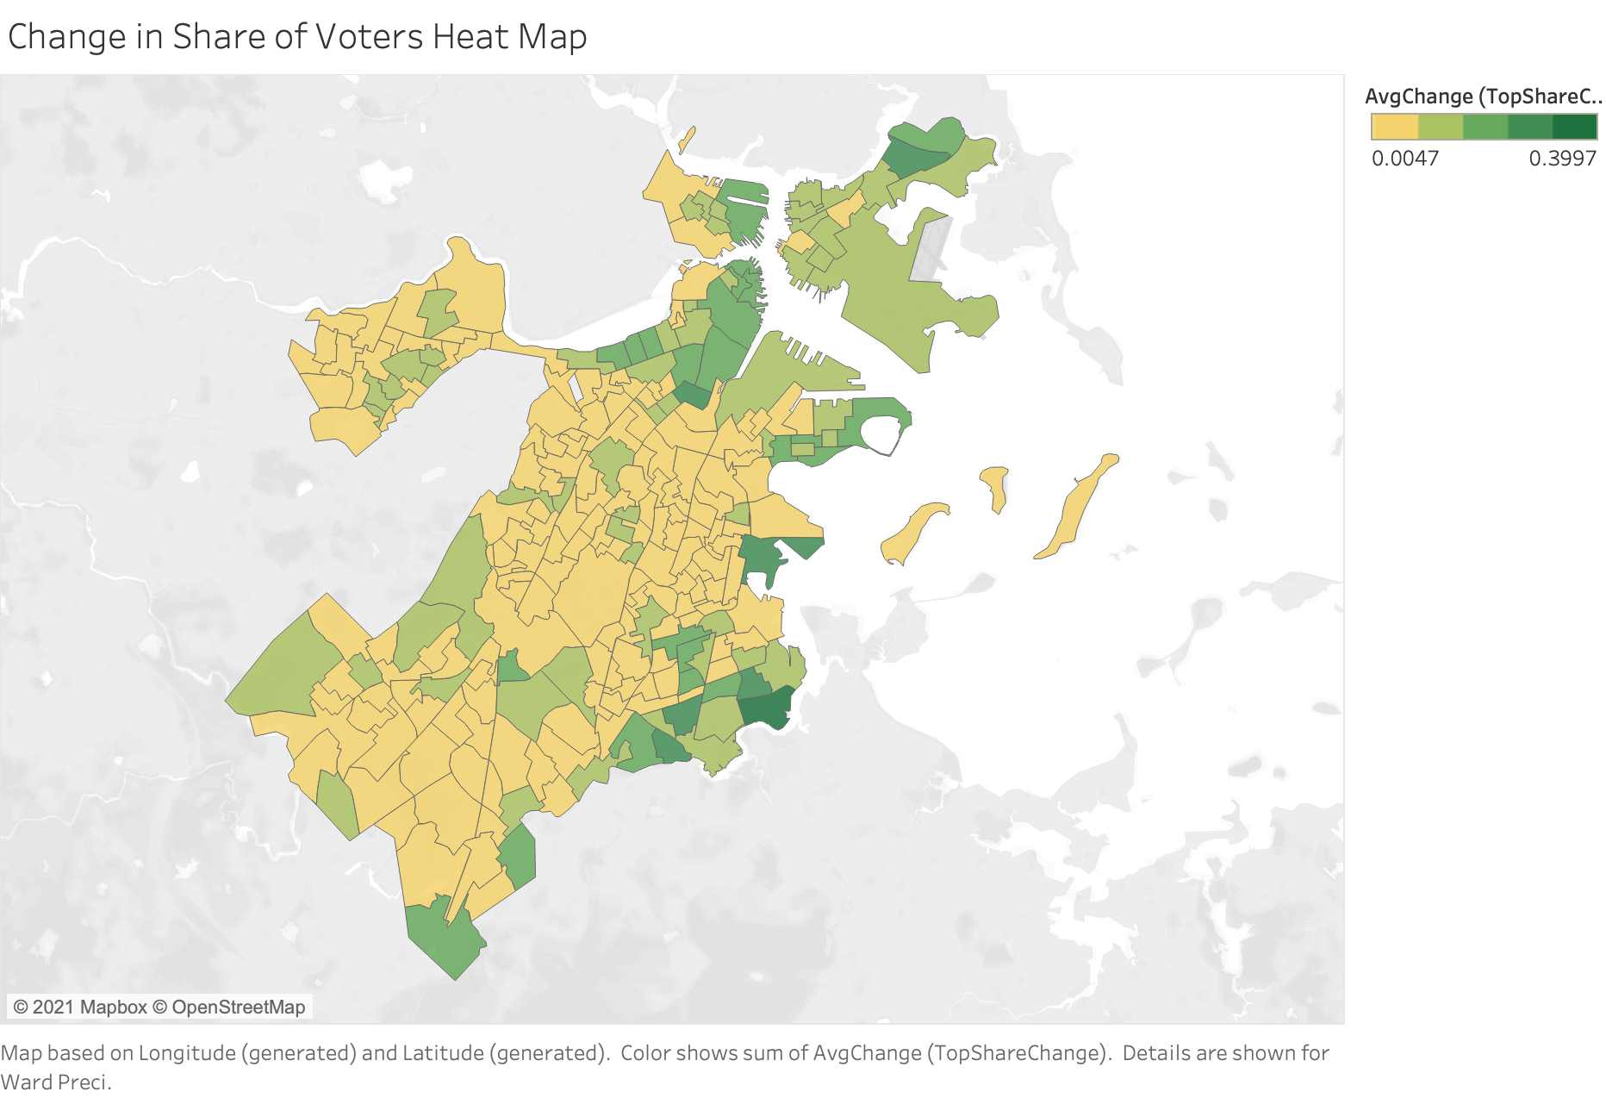

Here, the greens indicated those districts which have experienced a measurable change in share of total voter turnout. As we can observe, a lot of the intense green is concentrated in the Dorchester neighborhoods, as well as near downtown Boston, Seaport, and East Boston.

Some visual Analysis on Tableau Charts:

Compared percentage based off of Race, and their voting pattern (were they in unison or not)

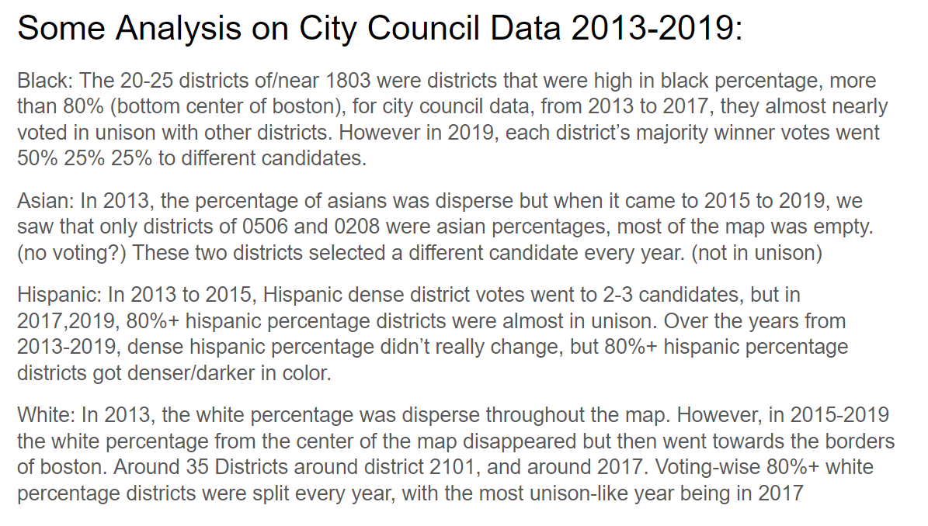

Unison means voting for the same candidate - only look at City Council At-Large

1. Note that we are excluding the 2019 City Council Race in this analysis for the time being since it is missing essential voter turnout data. However, we plan to add this to our analysis as soon as the data becomes available.